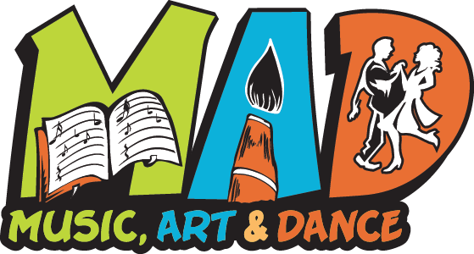
Music, Art, and Dance Camp
2019 Counselor Expectations:

Prior to Camp:
- Attend the walk through and in-service training of staff counselors. Date, time and location TBD.
- Assist with the moving of supplies and equipment, classroom set ups, and facility decoration on Sunday, July 21. The move will start at around 2pm and will finish no later than 6pm.

Week of Camp:
- Work 7:15am-5:30pm the week of camp (July 22-26, 2019)
- Attend any group functions the week of camp to include, but not limited to, the final performance on Friday.
- Interact with children and parents throughout the week.
- Assist Instructors and Counselors as needed in student guidance, facility maintenance, and conflict resolution.
- Help supervise classes, outside play, lunches, snack times, large group activities, and bathroom breaks.
- Help with other camp responsibilities as needed, including but not limited to arts and crafts, organization of supplies, and cleaning.
- Take primary directions from the MAD Camp Administrator (Anna) and secondary directions from all other adults as needed.
- Talk honestly with the camp administrator about any problems so we can work towards resolution.
- Participate in morning meetings with Anna at 7:15am to discuss prior day difficulties & any daily changes that may be needed.
- Take your break when scheduled.
- Communicate with teachers if you need to leave the room for any reason. Report to Administrator first for reassignment if the teacher dismisses you.
- Complete daily sign in/out form for counselors by check in table. Final gifts will be based upon hours logged as well as work ethic.

Post Camp:
- Participate in wrap up meeting and dinner at the conclusion of camp on Friday.
- Assist with clean up and disassembly of camp Friday evenings until 8pm.
- Offer feedback to staff regarding camp experiences and suggestions so we can improve our services.

Music, Art, and Dance Camp
Returning Counselor/Intern Application I am applying to be a: (check one)
- Junior Counselor (ages 13-16)
- Senior Counselor (ages 16+)
- Intern (ages 18+ with experience,
training, or courses in related fields)

Full Name:_________________________________________ Preferred Name:______________
Birth Date:_____________________________ Age (as of 7/12/2017):____________________
Address: ______________________________________________________________________
______________________________________________________________________
Home Phone:_______________________________ Cell:_______________________________
E-mail address:_________________________________________________________________
What is the best way to contact you? (circle one) home phone cell email text
T-shirt size: (Adult 100% cotton) Small Medium Large X-Large XX-Large
Preference of ages to work with (4-5, 6-7, 8-9, 10-12) 1st choice _________ 2nd choice________
Do you have any extra-curricular activities (including jobs) that may conflict with camp meetings or responsibilities? If so, please explain and give dates and times that may be conflicting. ______________________________________________________________________________________________________________________________________________________________________________________________________________________________________________________________________________________________________________________________________________________________________________________________________

- Check box if you need a letter of recommendation or confirmation of hours worked

**Applications should be received no later than May 31, 2019.

Please send completed application to:
Music, Art, and Dance Camp c/o Anna Penn, Administrator,
1031 Carol Street, Jefferson City, MO 65101

